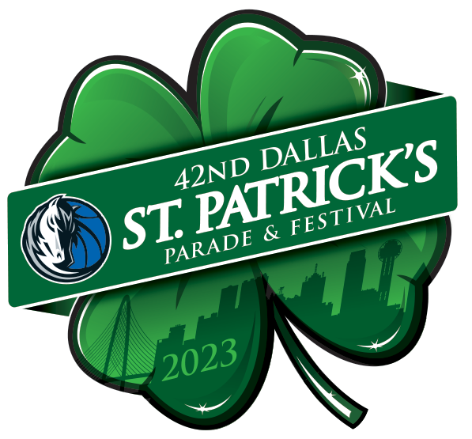

FOR IMMEDIATE RELEASE

Media Contact
Cristina Uranga
480-252-6157
ECHO Publicity
cris@echopublicity.com

Greenville Avenue Area Business Association Officially Announces
The 42nd Annual Dallas Mavericks St. Patrick’s Parade & Festival on Saturday, March 11, 2023, featuring Grand Marshal and City of Dallas Mayor Eric Johnson

The largest St. Patrick’s parade in the Southwest returns this year, continuing one of Dallas’ best traditions, with proceeds benefitting the G.A.A.B.A. Scholarship Fund for graduating Dallas ISD high school seniors.

(DALLAS – February 28, 2023) – The Greenville Avenue Area Business Association (G.A.A.B.A.) is proud to announce the 42nd Annual Dallas Mavericks St. Patrick’s Parade & Festival on Saturday, March 11, 2023, presented by the Dallas Mavericks – the parade’s top sponsor since 2016. The parade will begin at 11 am on Greenville Avenue at Blackwell Street and end at SMU Boulevard and Central Expressway. The festival will run from 9 am until 3 pm.

Attended by over 125,000 people each year, the largest St. Patrick’s event in the Southwest returns with live music, floats, food trucks, and an Irish spirit of celebration, featuring City of Dallas Mayor, Eric Johnson, as this year’s Grand Marshal.

“Every year we look forward to one of the biggest events in Dallas, the St. Patrick’s Parade, and this year we are thrilled to partner with the Dallas Mavericks to bring that vision to life,” said Kevin Vela, Board Chairman of G.A.A.B.A. “The Mavs organization has been our number one sponsor for many years and a phenomenal parade partner. We’re proud to work together to bring top notch family-friendly entertainment to the community while making a valuable contribution to DISD high school seniors rough our educational scholarship fund.”

Featured Events
The parade has delighted families and children for more than 40 years and has attracted some of the best entertainment in the Metroplex. Featured event activities are open from 9 am to 3 pm. Noted events include:

MORE

- CW33 (KDAF) Parade Live Broadcast will run from 11 am -1 pm at 5252 Greenville Ave.
- The Festival Zone will be situated at 5111 Greenville Ave. (Office Depot/CVS) and will feature food trucks, exhibitor booths, sponsor exhibits, family friendly activities, and a VIP Tailgate Area.
- The 5th annual Comerica Bank Family Zone is located at Lovers Lane and Greenville Avenue and will be equipped with arts and crafts, kids activities and treats for the entire family (no alcoholic beverages allowed in this area).

“The Mavericks are excited to renew its partnership with G.A.A.B.A. in 2023 to showcase one of Dallas’ most beloved traditions,” said Cynt Marshall, Dallas Mavericks CEO. “We love bringing the community together, and as a presenting sponsor, the Dallas Mavericks are showing up big with the Mavs Express bus, Mascots, and ManiAACs.”

Scholarship Goals
Proceeds from this year’s parade will go toward the G.A.A.B.A. Scholarship Fund, which has awarded over $150,000 to graduating high school seniors in DISD in previous years. Each year, G.A.A.B.A. awards up to $15,000 to select students at Conrad, Wilson, and North Dallas High Schools.

Online donations can be made at https://DallasStPatParade2023.eventbrite.com Click: “select a time” and then “tickets.” Scroll to the bottom for the Donations box and enter your desired amount.

“Our goal this year is to raise $42,000 in donations, which aligns with celebrating the parade’s 42nd year.

Event Sponsors
- Presenting Sponsor: the Dallas Mavericks.
- Official Parade Sponsors: 7-Eleven, Comerica Bank, Visit Dallas Tourism Public Improvement District, University Crossing PID, DART, Dallas Blonde, Deep Ellum Brewing, WGU Texas and Thomas J Henry.
- Media Sponsors: CW33, iHeart Radio, Lonestar 92.5, Star 102.1, 97.1 The Freak, 102.9 NOW, and 106.1 KISS FM.
- Festival Partners: St. Paddy’s Day DASH, US Energy Square LLC, Meadows Building at Energy Square, Half Price Books, Versa Printing Inc., American Golf Cars Irving, DoubleTree by Hilton Dallas-Campbell Centre, Buyers Barricades, Revel XP Elite Fan Experiences, and The Gild.

Timing & Transit Tips
The parade will begin at 11 am, but the public is invited to arrive on Greenville Avenue for festivities beginning at 9 am. Because of the crowds and popularity of the parade, visitors should plan to arrive early and leave late. The festival runs from 9 am until 3 pm.

The parade route starts on Greenville Avenue at Blackwell Street—with street closures scheduled to start at 10 am for north and southbound lanes of Greenville Ave—and ends at

MORE

SMU Boulevard at Central Expressway. Alternative routes around the parade area include Loop 12, Mockingbird Lane, and Park Lane with access to Skillman. Parade-goers are encouraged to
ride share or ride the DART Rail, as parking is extremely limited. Recommended DART Rail stations include Mockingbird Station, Lovers Lane Station, and Park Lane Station.

About G.A.A.B.A. & the Dallas St. Patrick’s Parade & Festival
The Greenville Avenue Area Business Association (G.A.A.B.A.) was formed in 1987 to help unifybusinesses in the area and to promote the Greenville Avenue region. Its first objective is and always will be the presentation of the annual Dallas St. Patrick’s Parade & Festival. The Parade has grown to be one of the largest St. Patrick's Parades in the country, with over 125,000 attendees and more than 100 parade entries. Proceeds go toward the G.A.A.B.A. Scholarship Fund, benefiting Dallas ISD high school seniors. Currently, more than $150,000 in scholarships have been awarded.

About the Dallas Mavericks
The Dallas Mavericks play in the Southwest Division of the Western Conference of the National Basketball Association (NBA) and began as an expansion franchise in 1980. The Mavs have won one NBA Championship (2011), four division titles (1987, 2007, 2010, 2021), and two conference championships (2006, 2011). The team is led by Owner Mark Cuban, General Manager Nico Harrison, and Head Coach Jason Kidd. In addition to on-court success, the Mavs are committed to making a difference in North Texas through outreach programs and the Dallas Mavericks Foundation. Learn more at www.mavs.com.

# # #

